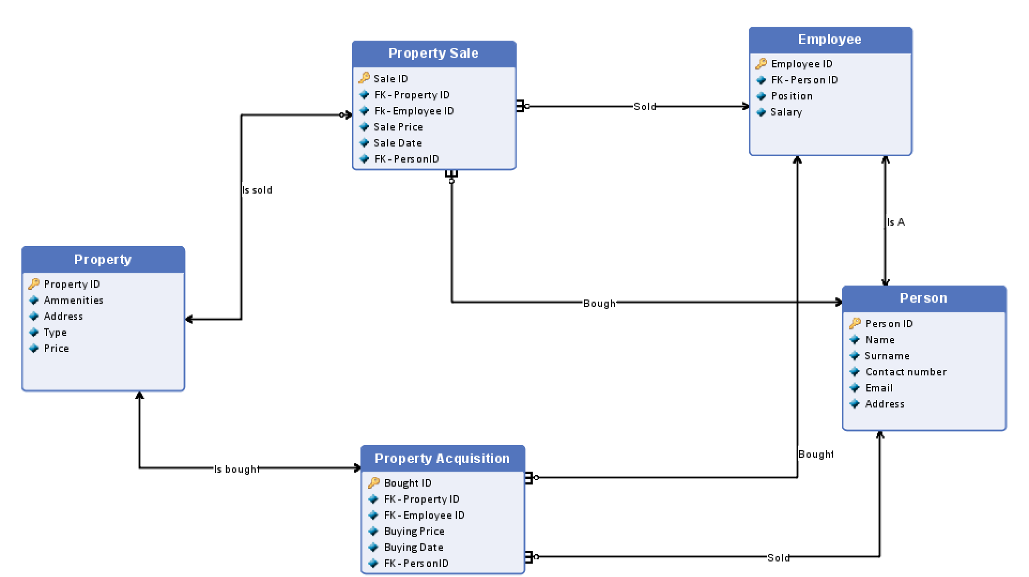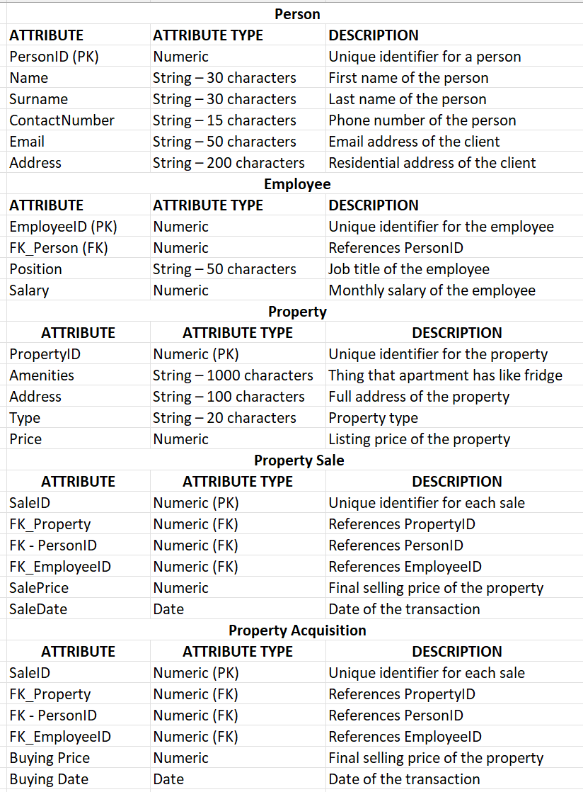

  - Marketing excel
Sheet 1 (Information about marketing in the real estate agency, each line describes one apartment, line 1 is a header row):
Column A: Property ID
Column B: Money Spent on Marketing
Column C: Number of Views on Our Website
Column D: Number of Views on Competition Website
Column E: Money Spent on Competition Website
Column F: Number of Views on Social Media
Column G: Money Spent on Social Media
Column H: Starting date of the campaign
Column I: Ending date of the campaign

